Inshore Participatory Monitoring (IPM) Workshop

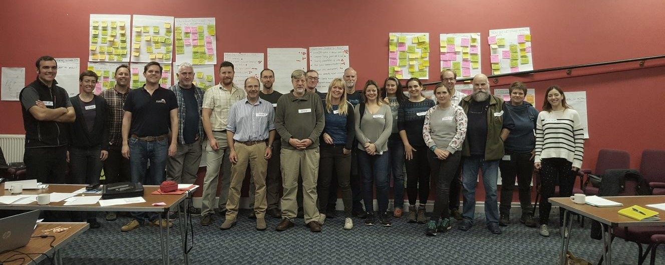
Meeting Notes

1st November 2017, 9am – 5pm
Corran Halls, Oban

Contents

1. Workshop Agenda 3
2. Participants 4
3. Local monitoring interests 5
4. Local monitoring interests’ priority ranking 8
5. Local initiatives in action 11
6. Local initiatives in action’ priority ranking 14
APPENDIX 1 15
APPENDIX 2 17

Workshop Agenda
9:00: Tea and coffee (30 mins)
9.30: Workshop Overview & Icebreaker session (20mins)
9.50: SNH Update (10mins)
National marine monitoring programme for Scotland, wider seas measures and indicators
10.00: Your community & IPM (1hr 15mins)
Each rep has up to 3-5 minutes to present who their group is, what their role is within the group, what the groups interest is regarding IPM.
11.15: Tea break
11.30: Local monitoring interests? (1hr 15mins)
Breakout groups: capturing your specific interests - what, why, how?
12.45: Lunch
13.45: Local initiatives in action (1hr 30mins)
Breakout groups: obstacles / solutions / moving forward
15.15: Useful lessons from Citizen Science (30mins)
Presentations from Co-Coast and Seasearch
15:45: Tea break
16.00: Wrap up, next steps and open Q&A
17.00: Workshop close

Participants

Name | Association | Role
Andrew Rodger | Ocean Guides - Harris | Group Rep/Individual
Andy Jackson | CAOLAS | Group Rep
Annabel Lawrence | CAOLAS | Group Rep
David Ainsley | Sealife adventures | Group Rep/Individual
David Bailey | Glasgow University | Individual/Academic
Hannah Grist | SAMS/ CO-COAST | Speaker
James Merryweather | South Skye Seas Initiative | Group Rep
Kerri Whiteside | Fauna & Flora International (FFI) | Facilitator
Lisa Kamphausen | SNH | Speaker
Mairi Fenton | SNH | Facilitator/Observer
Manuela de los Rios | COAST | Group Rep
Mark Smith | Friends of the Sound of Jura | Group Rep
Noel Hawkins | Scottish Wildlife Trust- Ullapool | Individual/NGO Rep
Owen McGrath | SNH | Facilitator
Owen Paisley | Seasearch | Speaker
Peter Cunningham | Wester Ross Fisheries Trust | Group Rep
Philip Price | CROMACH | Group Rep
Rebecca Plant | Fauna & Flora International (FFI) | Facilitator
Sara Nason | Sea Change Wester Ross | Group Rep
Sarah Russell | St Abbs & Eyemouth VMR | Group Rep

Local monitoring interests
Breakout groups: capturing your specific interests – what, why, how?
The answers to the questions below are broad themes which have been interpreted from a more extensive list of answers, please see Appendix 1 for the full list from each group.
Group 1: Manuela, Peter, Andy J., Hannah, Owen P., Annabel – Facilitator: Kerri
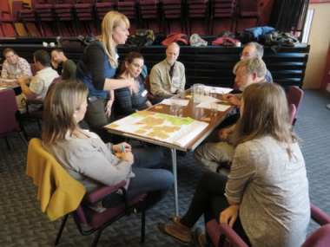
Q1: What do you want to know?

- Habitat use of fish
- Reporting and governance
- MPA data
- Environmental
- Socio-economic
- Fisheries/vessels
- Specific species interests
- Other:
- Who wants Seasearch help? How can we help?
Workshop Group 1 (image J. Merryweather)
- Funding
- Does my local MP know we exist?
Q2: Why do you want to know?

- Protection/management
- Evidence
- Defining impacts
- Policy/MPAs
- Enforcement
- Communities
- Other:
- For me: personal enjoyment of healthy marine ecology
- To answer questions raised in Q1
- To target activity and resources of Seasearch appropriately

Q3: How will that information be used?

- Improve management/protection/enforcement
- Community needs
- Communication
- Engagement/behaviour change
- Environmental improvement

- Other:
- To brand Arran as a “green blue” destination
- Living/working seas
- To create themed marine tourism opportunities

Group 2: Sara, Sarah, Mark, Andrew, David B. – Facilitator: Rebecca
Q1: What do you want to know?

- Species
- Habitats
- Threats
- Socio-economic
- Management/MPAs

- Other:
- Methodology to create standardised monitoring techniques for comparable data sets
- What the community needs to know and the extent of the interest
- Project design is vital in creating citizen science projects (citizen driven)
Q2: Why do you want to know?

- Evidence
- Protection/restoration
- Policy/planning
- Communities
- Communication/engagement
- Other:
- Curiosity
- To map the whole MPA
- Long-term thinking not short-term
Q3: How will that information be used?

- National/Policy/Management
- Communication/Engagement
- Community/campaigning
- Create frameworks
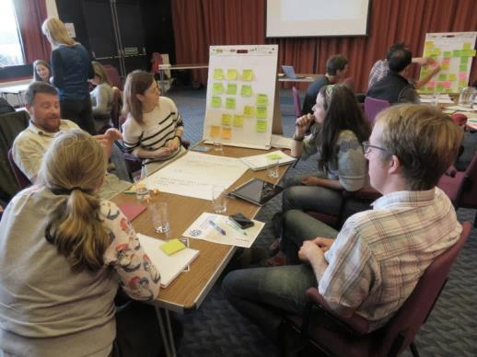
Workshop Group 2 (image J. Merryweather)
Group 3: Noel, Phillip, Calum, David A., James – Facilitator: Owen
Q1: What do you want to know?

- Presence/absence/abundance
- Quality/value
- Species related
- Habitat level
- Data/technical
- Community/group
- Socio-economic
- Environmental

Q2: Why do you want to know?

- Planning/Management
- Evidence
- Protection/regeneration
- Communication/education

Q3: How will that information be used?

- Policy/campaigning
- Management
- Sharing
- Engagement/learning

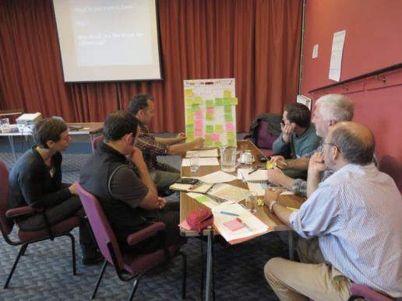
Workshop Group 3 (image J. Merryweather)

Local monitoring interests’ priority ranking
One top priority vote from each participant or group using the headline themes identified in the local monitoring interests session breakout groups.
Q1: What do you want to know? | Broad Theme | Votes
 | Ecosystem health | 6
 | Habitat and species distribution | 5
 | Water quality/toxins/pollutants | 5
 | Local baseline knowledge/awareness | 4
 | Fisheries activities and impacts | 3
 | Fish (everything related) | 1
 | Priority Marine Features (PMFs) | 1
 | How to do it and fund it | 1
 | Levels of resource use in seas | 0

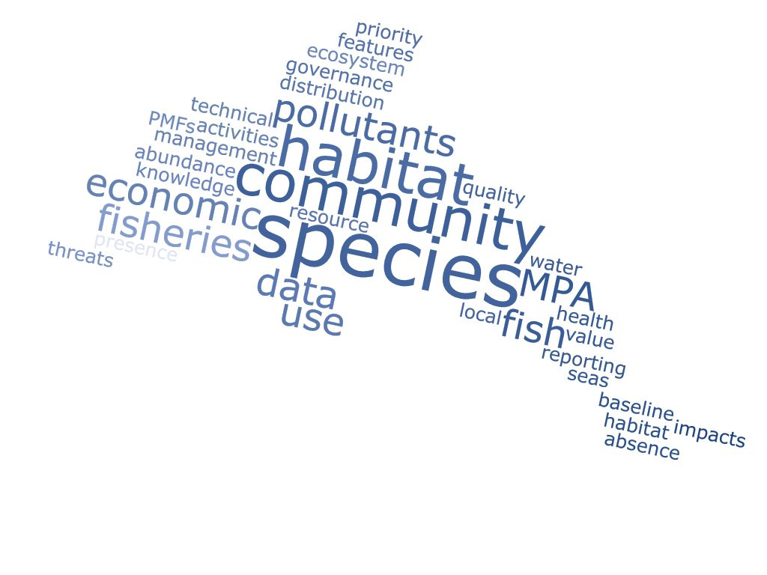
Wordcloud of responses to Q1

Q2: Why do you want to know? | Broad Theme | Votes
 | Community ownership and stewardship | 8
 | Influence policy | 8
 | To inform local and regional management | 4
 | Communication and education | 4
 | Enhance fisheries management | 1
 | Improve enforcement and compliance | 1
 | MPA capitalisation | 0
 | Cultural livelihoods | 0
 | Personal enjoyment and interest | 0
 | Maximise economic value | 0
 | To empower those involved | 0

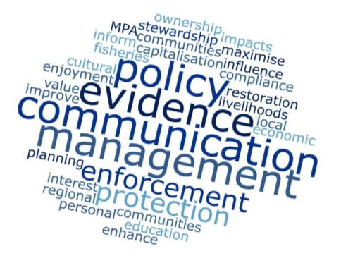
Wordcloud of responses to Q2

Q3: How will that information be used? | Broad Theme | Votes
 | Enable local participation in decision-making | 10
 | Plan future research and monitoring | 5
 | Increase community support and involvement | 4
 | Sharing communication of data | 3
 | Support skills development | 2
 | Campaign/lobby (present data to gov') | 1
 | Support/oppose marine developments | 1
 | Enable better compliance records | 0

Local initiatives in action
Breakout groups looking at obstacles / solutions / moving forward.
The answers to the questions below are broad themes which have been interpreted from a more extensive list of answers, please see Appendix 1 for the full list from each group.
Group 1: Manuela, Peter, Andy J., Hannah, Owen P., Annabel – Facilitator: Kerri
Q1: What are the obstacles to your group gathering data?
- Lack of capacity/knowledge
- Lack of resources/equipment
- Lack of statutory support or interest
- Lack of community or local engagement
Q2: What solutions could there be to these obstacles?
- Staffing/extra capacity
- Education/outreach
- Funding/resources
- Collaboration/networking
- Statutory actions
Q3: How would you like this process to move forward? What part would you like to play?
- Activities:
- Up to a few hectares (adjacent to snorkel trail) for an education/study area
- Underwater calendar of what to look out for
- Develop protocol for finding wrasse nests and how to monitor them
- Stock assessment before wrasse fishery
- Engage more University teachers/students in participatory monitoring for their projects
- Make use of existing apps and guides/projects (ie. Nurdle, jellyfish, seaweed, seagrass, marine mammals).
- Themed years for MPA monitoring: 2018 – Dolphin spotting, 2019 – Seaweed recording etc.
- Provide awards for the most productive/biodiverse underwater area
- 10 top facts on MPA features
- AIS for all dredgers
- EIA before dredging
- Common support to individual projects
- Start: simply clean the beaches with community groups, have BBQ and explain complex MPA work
- Launch initiatives, eg. 1. Where does your fish come from?, 2. How much plastic can you collect?
- Stock take of which communities have equipment so we could share
- Provide local creel fishermen and kayakers or anglers with equipment and protocol to record spawning herring
- Set up monitoring cameras at hotspots to show the activity going on underwater
- Public awareness to projects
- Joint funding bid for all MPA groups to do the monitoring
- Could use the coastal communities network website for each group to share their monitoring projects
- Who does what:
- Scottish government to enable local community/schools to adopt or lease seabed area to manage (= sense of ownership)
- Get the head of Scottish Government to attend meetings like this
- SNH/MS/Communities “gap map”
- SNH, Glasgow Uni, others? To train communities how to best follow methods: drop downs, drones, transects etc.
- Local fishing trusts can lead on some activities
- Visit Scotland to engage with MPAs
- Local MPA groups to take their own project forward with outside support
- A new body to coordinate all the agencies and groups involved

Group 2: Sara, Sarah, Mark, Andrew, David B. – Facilitator: Rebecca
Q1: What are the obstacles to your group gathering data?
- Funding/resources
- Staff/capacity
- Support
- Logistics
- Campaigning
Q2: What solutions could there be to these obstacles?
- Funding
- Support
- Staff
- Value
Q3: How would you like this process to move forward? What part would you like to play?
- Joined up thinking needed
- More partnerships means stronger outcomes
- Action
- A national coordinator for delivering projects
- Community groups in partnership with academic and government bodies and other parties
- Building community ownership through upscaling community groups
- Create an inclusive community plan for surveys
- Key words noted: Inclusive, collaborative, joined-up, partnerships
Group 3: Noel, Phillip, Calum, David A., James – Facilitator: Owen
Q1: What are the obstacles to your group gathering data?
- Lack of capacity/knowledge
- Lack of resources/equipment
- Lack of statutory support or interest
- Logistics
- Values/industry
Q2: What solutions could there be to these obstacles?
- Funding/resources
- Support
- Staff
- Collaborating/networking
- Outreach/education

Q3: How would you like this process to move forward? What part would you like to play?
- Links to networks
- Building capacity
- Shared and sharing resources
- Communications and social media

Local initiatives in action’ priority ranking
One top priority answer from each participant or group to the three questions posed in Session 5: Local Initiatives in Action.
Question 1: Obstacles
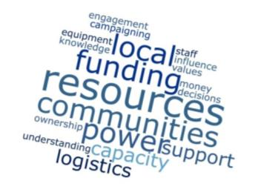
- Power and money of destructive marine industry sectors e.g. fish farms/dredging/pollution etc.
- Lack of a sense of ownership of marine assets by local communities
- Power/resources/funding of opposition
- Lack of understanding of the marine environment and the value it holds for local communities
- Lack of power of local communities to influence decisions related to the marine environment
- Inability to upscale without funding – split between protecting MPA and positive survey and communications with the community. Much easier to focus on citizen science if MPAs are sacrosanct and don’t have to be defended.
Question 2: Solutions
- Sharing resources and data
- Creation and sharing of resources and data to action and lobby
- Demonstration areas where local communities can benefit from participation in monitoring and management
- Local groups and ‘experts’ delivering local and national objectives
- Devolving power to local communities
- SACs and MPAs need protected status: presumption against damaging activities
Question 3: Going forward
- Pooled resources on the coastal communities network website
(e.g. Presentations, research, letters to MPs, responses to consultations)
- Funding for programme of co-management projects focusing on biodiversity and fisheries, to link inshore marine areas with local communities
- Joint MPA-watch project for all communities which could get funding as an umbrella project
- Joint funding survey approach for the coastal communities network and allowing each group to also do their own thing

APPENDIX 1
Your community & IPM
Annabel & Andy Jackson - CAOLAS formed in summer 2014 in response to the designation of the local MPAs, big part of role is to inform locals of the designation, promote it, work with everyone who has an interest, don’t want to de divisive. Bring underwater wildlife and wrecks etc. to life, use it also for tourism. Just getting properly constituted now, members around 50 or 60 and increasing.
Andrew – how can we make the sea work for us – get involved in the seas and tourism.
Sarah – St Abbs VMR set up as a charity33 years ago– community wanted something to happen, it was and still is a top dive site. A code of conduct was put in place between the divers and creelers. The VMR also has overlapping SAC and fisheries designations. Some years ago it was hard for people to find time to commit and enthusiasm dipped but now St Abbs VMR has a new committee and is reengaging with stakeholders and the community. In the future would like to gather baseline survey to develop detailed map of the habitats to assist with monitoring and management. Intention is to use technology to deliver increase marine literacy and community ownership of the VMR.
David B – Uni of Glasgow with links to the Glasgow Science Festival. Interested in a long term commitment – to be able to influence policy and make a real change in terms of better decision making and outcomes for marine conservation in Scotland. Would like to contribute genuine effort for genuine results for Scotland’s seas.
Manuela- COAST established no take zone in 2008 and subsequent NCMPA in 2014. Active organisation and community base with 30-40 active members focussed on research, education and campaigning. This summer a university made a comparative study into the marine life inside and outside NTZ. The results have been used for communication around the difference the NTZ is making. Working to get more people involved. Would like to use technology to collect data but ensure data collected is useful. Working on developing a marine centre and engaging tourists in monitoring.
James -SSSI currently three active members. They have seashore data and point dataset but would like to map out the whole of the sea lochs. Previous grant application failed and would need a project manager and some funding to take this forward. Have or soon will have an underwater drone TRIDENT to help gather baseline data and map. 11 types of crabs have been recorded so far from shoreline surveys.
Sara - Sea Change Wester Ross formed around a creel petition, small core membership including Sara and a data scientist with good community support and strong links to community including fishermen, artists and schools. Would like to pioneer a model of community led MPAs. Continue to seek funding to take ideas forward including long term monitoring of the MPA. Building social media resources including films and working with David B from UoG.
David Ainsley – Been living and working in Firth of Lorn for 30-40 years and been involved in lots of groups over the years to support the marine environment. Would like to see existing laws properly enforced and encouraging to see the changes in attitude by government agencies in recent years. Feel as though they missed the opportunity to put in place monitoring years ago. However, has seen on own surveys remarkable recovery of some areas, habitats and species, jewel anemone, increased fish populations and harbour porpoise as examples. There is a significant issue with Acoustic Deterrent Device use on fish farms and impacts on harbour porpoise. People would like to know that things are recovering. Change and restoration happens at a slow pace and micro level.
Philip - CROMACH is a fledgling group based around Ardfern with around 50-60 members and good community support. Currently building community awareness of local marine environment and improve links to folk who make a living from the sea, it’s not about conservation but RESTORATION! Volunteers are mobilising with boats, divers and Seasearch. Currently working on communication with fishermen regarding sustainability issues. Would like to explore the MPA boundaries being extended into Loch Craignish.
Peter C – WRFT based in Gairloch with a small local trawler and creel fishing fleet, Peter was engaged with the Wester Ross MPA from the beginning. Would like to see a bit more join up between statutory agencies. Working on links between freshwater fish and marine habitats such as maerl as herring spawning grounds and interactions with dredgers. Additional concerns about the wrasse fishery which has come on in recent years, and the impact of this on the wrasse populations and marine ecology. Exploring links with the WR Biosphere and whether this could be extended into the marine environment.
Noel- SWT based in Ullapool. Have worked with CoCoast. Currently coordinate local events including seafood festival and fishing competitions. Working on communications around MPAs not being a threat and countering the anti MPA voice. Have engaged with over 380 children including getting over 90 of them into the sea, and have brought children up from Sunnyside School in Glasgow. Developed and rolled out the Snorkel Trail for WR MPA. Trying to get the local dive clubs involved and have recently purchased an ROV to be used for communications, engagement and undertaking preliminary survey work. It is important to understand and know what you are looking at when surveying, example of flame shell bed.
Mark – FoSoJ has a core group of six or seven which came together around fish farm application which was inside MPA and close to a salmon river. Efforts to date have discovered community members who are interested in marine issues and would like to engage with these people more. See value in surveying local area and capturing the existing knowledge within the community which can reveal invaluable insights. Would like to develop base knowledge of the area and bring community with them.

APPENDIX 2
Full answers to break-out Session 1 - Local monitoring interests
Group 1: Manuela, Peter, Andy J., Hannah, Owen P., Annabel – Facilitator: Kerri
Q1: What do you want to know?
Theme: Habitat use of fish
- How do fish populations vary according to seabed habitat integrity?
- Do wrasse feed on octopus eggs?
- How important are seabed habitats for herring recruitment and productivity of local (e.g. spring spawning) populations?
- Are maerl beds used by herring for spawning?
- Abundance of food fish for sea trout in different habitats
- Location and condition of seabed habitats of importance to fish
- Breeding habitat for wrasse
- Spawning habitat for herring
- Food and cleaning behaviour of wrasse species (x5) in the wild
Theme: Reporting and governance
- How to report rough, illegal fishing?
- How do we report illegal activity?
- How to set up multi-group interaction
- How to record seabed info – store and share
Theme: MPA data
- What data exists already for our MPA? Who holds the data? How do we access it?
- What species live in the MPA and are they important?
- How much marine traffic is there in the MPA?
Theme: Environmental
- How to monitor plastic pollution
- Water quality
Theme: Socio-economic
- What is the local fishing industry worth in Scotland? How many jobs does it support?
- Social and economic impact of an MPA
- The worth of marine tourism
- Energy options for marine traffic? Electric vehicles?
Theme: Fisheries/vessels
- Where do the fishing vessels come from? Who owns the fishing fleet in Scotland?
- What is being fished and how much
- Incursions of trawlers/dredgers/creelers in the MPA
- How many fishing boats are active in the MPA?
- Creeling effort
- How healthy is the scallop fishery?
- Impacts of anchoring and other non-fishing activities
Theme: Specific species interests
- Are there skate spawning grounds around Wester Ross?
- Egg habitat for skate
- What animals feed on octopus eggs and why do the octopuses guard them?
- Where do skate lay their eggs? In our MPA?
- Evolution status and mapping of seagrass beds (i.e. sargassum/epiphyte)
- How changes in pressures impact the ecosystem as a whole (e.g. Wrasse being removed)
Theme: Other
- Who wants Seasearch help? How can we help?
- Funding
- Does my local MP know we exist?

Q2: Why do you want to know?
Theme: Protection/management
- To be able to better protect important places for fish
- To know what is most important to protect and manage
- To understand how best to target resources towards recovery of fish populations
- To be able to inform local stakeholders and government agencies
- To know what management measures and needed to protect wrasse populations
Theme: Evidence
- To dispel myths about sustainable fishing
- Evidence based debate instead of anecdotal
- Are restoration projects/measures working?
Theme: Defining impacts
- To know how salmon farm/agricultural runoff and other impacts affect the water and seabed
- To help organisations’ aspirations on marine conservation and help us to achieve Scotland-wide recovery
- To be able to understand and communicate how a “missing” feature impacts the whole ecosystem
Theme: Policy/MPAs
- To change policy from the government
- To monitor change, uses and trends to demonstrate to the government the success of an MPA
- To make the case that MPAs work (and being sure they do)
- To review management measures of MPAs (e.g. limit anchoring, aquaculture)
Theme: Enforcement
- To get successful prosecutions for breaches of MPAs
- To improve protection and enforcement
- So people get feedback on the impact of them reporting non-compliance (how many go to court, fines etc.)
Theme: Communities
- To improve culture and become better at looking after the marine environment
- To engage and empower people locally (so they don’t just “delegate” because they feel they don’t have enough knowledge)
- Maximise economic value of inshore areas for local communities – without compromising biodiversity and opportunities for future generations
Theme: Other
- For me: personal enjoyment of healthy marine ecology
- To answer questions raised in Q1
- To target activity and resources of Seasearch appropriately
Q3: How will that information be used?
Theme: Improve management/protection/enforcement
- Improve management
- Rebuild fish populations
- Informed co-management (local community and government support)
- Set up demonstration management projects/areas
- To make guilty parties accountable
- Management systems that work
Theme: Community needs
- Spend time more effectively
- Provide sustainable involvement for everyone engaged in marine activity
- Self tune to local needs
- Integrate in community’s daily life – knowing how healthy and diverse their seas are and keeping an eye on changes
Theme: Communication
- Bring pressure on government to legislate change
- To present evidence to government
- Write to MSPs/ministers etc. and to raise the profile, the positive impact of MPAs on nature, people and longer-term economy (local)
Theme: Engagement/behaviour change
- Ground work for education and schools
- To improve ocean literacy amongst the public (inc. education)
- To stop deleterious behaviour and attitudes to the marine environment
- To empower everyone to care about the marine environment
- Engage more communities that support MPAs/effective marine management – prove we can make a difference
- Raise profile/awareness
- Get public in, on and under the water
- To produce interpretation of MPA for the public
Theme: Environmental improvement
- Clean up plastic waste in water and seabed
- Clean up the plastics that are visible on the beach
Theme: Other
- To brand Arran as a “green blue” destination
- Living/working seas
- To create themed marine tourism opportunities

Group 2: Sara, Sarah, Mark, Andrew, David B. – Facilitator: Rebecca
Q1: What do you want to know?
Theme: Species
- Skate distribution, skate egg location
- Sea trout
- Salmon migration routes
- Climate change indicator species and invasive species
- Abundance & distribution of species
- Herring
- Spiny lobster
Theme: Habitats
- Quality & abundance of qualifying features for the protected area (MSAC) (rocky reefs, sea caves, seals)
- Ecosystem interactions
- Priority marine features
- Maerl beds
- Seagrass
- Flameshell reefs
- Burrowed Mud
Theme: Threats
- Acidification – level and impacts
- Climate change – effects and impacts
- Prawn trawling impacts
- Dredging transects
Theme: Socio-economic
- Ecosystem services
- Economic benefits
- Habitat and fisheries interactions

Theme: Management/MPAs
- Level of fisheries in the MPA
- Fisheries pressure around Maerl beds
- Need a “baseline” to build monitoring programmes
- Map baseline – monitor changes over time
- Management effectiveness (for MPAs or other regulated areas)
Theme: Other
- Methodology to create standardised monitoring techniques for comparable data sets
- What the community needs to know and the extent of the interest
- Project design is vital in creating citizen science projects (citizen driven)
Q2: Why do you want to know?
Theme: Evidence
- National scale knowledge
- Robust science to inform management and development
- Inform and engage consultations
- Prove our economy is underpinned by good ecosystems
Theme: Protection/restoration
- Restore beauty
- Restore fisheries
- To protect the ecosystem and prove that a thriving community = a good ecosystem
Theme: Policy/planning
- Inform regional marine planning to benefit the local communities
- Policy management
- Linking to national objectives
- Evaluation process
Theme: Communities
- Regenerate community (socio-economic)
- Know the cultural value of seas
- Community ownership connection
- Public ownership advancement
- Forming networks of knowledge and experts
- Community rights
Theme: Communication/engagement
- Involving and engaging communities to strengthen capacity and understanding
- Communication
- Tourism promotion
Theme: Other
- Curiosity
- To map the whole MPA
- Long-term thinking not short-term
Q3: How will that information be used?
Theme: National/Policy/Management
- Inform sustainable development
- Feed information into national level
- Influence policy management
Theme: Communication/Engagement
- Education – inspiring and involving the next generation
- Build appreciation and connection to marine life
- Tell stories, share with others
- Promote findings by the community to enhance attractions
Theme: Community/campaigning
- Define community rights
- Opposing developments (e.g. Fish farms)
- Build community assets (e.g. Discovery Centre)
- Redefine ownership
Theme: Create frameworks
- Using info for further research/monitoring
- Explore and build an inclusive and participatory model that works

Group 3: Noel, Phillip, Calum, David A., James – Facilitator: Owen
Q1: What do you want to know?
Theme: Presence/absence/abundance
- What is there?
- Priority features – where and what
- How accessible is it?
- How much is there?
- What isn’t there? (that should be, or was previously)
- Habitats and species presence/absence
- Historic information
Theme: Quality/value
- Why is it worth protecting?
- What is damaged and where?
- Habitat quality
- What level to restore to, restoration aims
- Examples of active restoration
- What damages or protects what is there
Theme: Species related
- Flapper Skate and egg cases
- Sound map for ADDs within Porpoise SAC
- Fish: spawning, feeding, migrating through
Theme: Habitat level
- Habitat mapping
- Seabed
- Long term fixed point benthic and fish monitoring in FOL SAC
Theme: Data/technical
- Guidance on non-diving survey work (shore line, drone etc.)
- How to manage data
- What data accepted and where to send it
- How Seasearch and MCS can help
Theme: Community/group
- How to involve the community
- Funding
Theme: Socio-economic
- How can jobs/income be improved
- Economic survey of MPAs and SACs where mobile gear is banned (esp. FOL SAC)
- Current economic activities
Theme: Environmental
- Toxin levels
- Water quality
- Where and what – marine usage and effects (e.g. Effluent, fish farms, boats, sewage)
- Pre fish farm data
Q2: Why do you want to know?
Theme: Planning/Management
- To see if the MPA works
- Include areas in MPA in future
- Baseline information to support or refuse development
- Create protection areas
- Support existing economic activities (e.g. Creelers)
Theme: Evidence
- Facts for combating threats to habitats
- To share data and resources
- Protected areas act as scientific “controls” (e.g. If cod stocks decline is it sea temperature rise or overfishing?)
- To show jobs and conservation can co-exist
- People support protected areas when improvements are obvious (e.g. Isle of man scallop closed areas now supported by fishers)
- Add to knowledge of Scottish seas
- Economic studies in FOL would be expected to show wildlife tourism and scallop diving worth more than before
Theme: Protection/regeneration
- Protect marine ecosystems for the future
- Create a target for restoration
- Improving sustainable use of area: fishing, tourism etc.
Theme: Communication/education
- Engage and keep engaged local community
- Encourage community ‘ownership’ of their environment
- Support community education
- To encourage public understanding and involvement
Q3: How will that information be used?
Theme: Policy/campaigning
- Removing/blocking/changing damaging activities
- Creating response documents (LDP, Marine planning, applications)
- Lobbying government
- To support Scotland-level advocacy for marine recovery through planning, MPAs and fisheries reform
- Support continued protection
Theme: Management
- Add to local environmental management
- Use data to inform decision making
- Use results of monitoring to inform future planning
- To see if protection is effective at achieving desired recovery and adjust management if necessary
- Prove fishing and conservation can coexist and improve income
- Rebuilding habitats (reefs etc.)
Theme: Sharing
- Pass info to other bodies e.g. SNH and planning authorities
- Feed into national databases
- Sharing – make it available to all
Theme: Engagement/learning
- To get local people involved in projects, planning, decisions
- Improve community understanding of the local environment
- Learning
- To engage people in the sea
- Social media and online messages
- Community events (films, talks, beach surveys, wildlife watches)
- Disprove negative propaganda
- Sometimes unexpected benefits follow protection (e.g. N.Z. more spiny lobsters eat urchins > kelp cover > more fish)
- Public support when benefits are seen
- Allocating actions to volunteers
- Encourage recreation and tourism
Full answers to break-out Session 2 - Local initiatives in action
Breakout groups: obstacles / solutions / moving forward
Group 1: Manuela, Peter, Andy J., Hannah, Owen P., Annabel – Facilitator: Kerri
Q1: What are the obstacles to your group gathering data?
Theme: Lack of capacity/knowledge
- Knowing what’s most important for policy change/gaps in knowledge
- Lack of knowledge about technology/good monitoring practice
- No survey protocols for monitoring fish and habitats
- Historic data not available or missing
- Not having the methodology to ensure the research is valid
- No admin support for small groups
- Need co-ordinator with GIS skills (and access to GIS)
Theme: Lack of resources/equipment
- Need for inexpensive drop down cameras
- Need for facilities at the beach (changing rooms etc.)
- Access to appropriate technology
- Technical training and equipment
- Who will fund?
- Funding, resources, time
- Access to boats/skippers
- No coastal field station (to provide accommodation for visiting groups)
Theme: Lack of statutory support or interest
- Different remit of SNH and MSS (habitat conservation vs. fisheries management)
- Conflicting agendas: conservation, renewables, oil & gas, aquaculture, fishing
- Lack of vision for the future
- Attitude to marine resources needs to change: not an infinite resource, rubbish dump etc.
Theme: Lack of community or local engagement
- No sense of community ownership and responsibility, apathy over involvement
- Need partner organisation to provide support to local community
- Difficult to prioritise: Education, awareness, monitoring, reporting, public engagement
- Do we know what we want? Is there a consensus?
- Lack of awareness among the general public
- Difficulties in communicating findings to local community to maintain interest
- Little marine conservation education for children in schools – engagement has to happen later
- Professionalisation of marine tourism sector
Q2: What solutions could there be to these obstacles?
Theme: Staffing/extra capacity
- Sharing seasonal staff to deliver education to schools during winter months
- Employ local monitoring and marine survey officers
- Apprenticeships in marine technology
Theme: Education/outreach
- Teaching marine conservation in schools
- Establish marine study and management area for each secondary (or primary school) in Wester Ross
- All schoolchildren should have experience of snorkelling after they have learned to swim
- Finding efficient ways to engage schools/college/volunteers and empower so they take ownership
- Work with Duke of Edinburgh and other outdoor/natural history groups
- Participatory monitoring campaigns to get more people on board
- Make it a fun and rewarding experience
- To engage young people: Explain the skills they will gain for future
- Create realistic goals and tasks that people can achieve (e.g. Pick up plastic)
- Make it accessible/ give different ways to participate
- Provide low cost drop-down cameras and training for volunteers (e.g. Scottish mink initiative)
- Publicise the work of MPA groups in positive light
- Set up a network of underwater webcams to watch fish
- Use technology and different media to promote the marine environment
Theme: Funding/resources
- More funding for coastal groups
- Joint funding applications (i.e. West of Scotland + SNH +…)

Theme: Collaboration/networking
- More integration of MPA groups but not cloning
- Talk to fishermen, explain the problem
Theme: Statutory actions
- Enforcement of MPA rules
- Political will based on public support
- Create clear demonstration sites

Q3: How would you like this process to move forward? What part would you like to play?
Activities:
- Up to a few hectares (adjacent to snorkel trail) for an education/study area
- Underwater calendar of what to look out for
- Develop protocol for finding wrasse nests and how to monitor them
- Stock assessment before wrasse fishery
- Engage more University teachers/students in participatory monitoring for their projects
- Make use of existing apps and guides/projects (i.e. Nurdle, jellyfish, seaweed, seagrass, marine mammals).
- Themed years for MPA monitoring: 2018 – Dolphin spotting, 2019 – Seaweed recording etc.
- Provide awards for the most productive/biodiverse underwater area
- 10 top facts on MPA features
- AIS for all dredgers
- EIA before dredging
- Common support to individual projects
- Start: simply clean the beaches with community groups, have BBQ and explain complex MPA work
- Launch initiatives, e.g. 1. Where does your fish come from?, 2. How much plastic can you collect?
- Stock take of which communities have equipment so we could share
- Provide local creel fishermen and kayakers or anglers with equipment and protocol to record spawning herring
- Set up monitoring cameras at hotspots to show the activity going on underwater
- Public awareness to projects
- Joint funding bid for all MPA groups to do the monitoring
- Could use the coastal communities network website for each group to share their monitoring projects
Who does what?
- Scottish government to enable local community/schools to adopt or lease seabed area to manage (= sense of ownership)
- Get the head of Scottish Government to attend meetings like this
- SNH/MS/Communities “gap map”
- SNH, Glasgow Uni, others? To train communities how to best follow methods: drop downs, drones, transects etc.
- Local fishing trusts can lead on some activities
- Visit Scotland to engage with MPAs
- Local MPA groups to take their own project forward with outside support
- A new body to coordinate all the agencies and groups involved

Group 2: Sara, Sarah, Mark, Andrew, David B. – Facilitator: Rebecca
Q1: What are the obstacles to your group gathering data?
Theme: Funding/resources
- Little allocation of resources to groups
- Sustainable funding (long-term) difficult to get
- Resources lacking. Not just economic.
- Long term investment difficult
- Lack of time to apply to grants
- Difficult to upscale small funding
- Hard to keep up momentum
- No core funding to keep groups running
Theme: Staff/capacity
- No paid staff in many groups
- Need for a survey facilitator or project coordinator who is sustainably funded
- More people power needed, to increase engagement
- Staff and volunteers can end up over-burdened and burning out
- Lack of recognition of non-paid work and community inputs
- The number of active committed members who have spare time is limited
Theme: Support
- Access to scientific advice needed
- Lack of support from NGOs to build community groups
- Differences in objectives between communities and the government bodies
- Little training or equipment available to community groups
Theme: Logistics
- Need for realisation of the value of the marine resource before seeking funding
- Difficult to access seas for research
- Lack of knowledge (science wise)
- Ensure data is of useable quality
- A lack of understanding of why and how
Theme: Campaigning
- Having to campaign whilst also working positively
- Ability to generate positive profile when campaigning
Q2: What solutions could there be to these obstacles?
Theme: Funding
- Structure to devolve funds and responsibilities
- Money
- Build community crowd-funding to fund surveys
- Funds for communications and community engagement
- More resources (e.g. IFCAs in England)
- Funding for equipment
Theme: Support
- Engagement and interpretation tools
- Communication systems
- Partnership working
- Knowledge sharing
- Empowerment for communities
- Support signposting
- Training for community groups
- Networking, gathering and working together
Theme: Staff
- Sustainably funded project officers for community groups
- Use of tour boat operators to collect data
- Staff with survey skills and knowledge
Theme: Value
- More value given to the sea and resources
- More passion for seafood and oceans
- Understanding the value of marine resources
- Changing perceptions of the marine environment
- More people to engage positively with community
- The government to change policy and to listen to science more
Q3: How would you like this process to move forward? What part would you like to play?
- Joined up thinking needed
- More partnerships means stronger outcomes
- Action and Building community ownership through upscaling community groups
- A national coordinator for delivering projects
- Community groups in partnership with academic and government bodies and other parties
- Create an inclusive community plan for surveys
Key words noted: Inclusive, collaborative, joined-up, partnership

Group 3: Noel, Phillip, Calum, David A., James – Facilitator: Owen
Q1: What are the obstacles to your group gathering data?
Theme: Lack of capacity/knowledge
- Limited specialised expertise
- Lack of project coordinator (funding)
- No access to standardised information (science, lobby etc.)
- No access to data
- More young people needed
Theme: Lack of resources/equipment
- Lack of equipment
- Lack of funding
Theme: Lack of statutory support or interest
- Local knowledge and understanding limited at higher levels
- Disparity of means and asymmetry of access – lack of a level playing field
- Access to free environmental justice
- Brexit?
- Lack of political will
Theme: Logistics
- Large area and population covered by groups
- Lack of time
- Difficult weather conditions
Theme: Values/industry
- Rich opposition
- Not enough engagement from within marine industries
- Us & them mentality/ apathy
- False dichotomy “jobs vs. conservation”
- Law works with money – restricts access to justice
- Vested interests
- Anti “experts” and the media
- Fake news
- Local community “bribes” as jobs from damaging marine industry
Q2: What solutions could there be to these obstacles?
Theme: Funding/resources
- Sharing resources
- Funding: project coordinator, equipment, community participation
- Funding for litigation
Theme: Support
- Dive and survey training
- Sharing data
- Sharing info, data, expertise and resources
- Online access to a database themed to requirement
- Organisation taking responsibility for coordination sharing between groups
- Access to scientific papers
Theme: Staff
- Pool volunteers
- Discovering local skills as yet unidentified
- More hard graft by the few
Theme: Collaborating/networking
- Coastal communities acting with common cause
- Acting strategically – playing to organisation’s strengths
- Working with government agencies and relevant NGOs
- Energetic participation in consultations, planning and decision making
- Joint campaigning (lobbying and online)
- Networking (coastal communities)
- Lobby voice from coastal communities
Theme: Outreach/education
- Access to films, images, stories to share in local community events
- Educating at local level
- Promoting positives
Q3: How would you like this process to move forward? What part would you like to play?
Theme: Links to networks
- MCS sea champions
- Bi yearly coastal community network event
- Find expertise in identification and link with
- Lobby MSPs, relevant species champions
Theme: Building capacity
- Community groups: matching people’s tasks to their skills
- Plan: Scotland and plan of plans
- Building citizen science capacity (seasearch/co-coast)
- Making activities more accessible
- Make best use of existing resources
- ID and video training event
Theme: Shared and sharing resources
- Indexed and searchable dropbox file system on communities website
- Visits to other locations to share best practice (community groups)
- Pooled equipment: drones, dive equipment, videos
- Talk to one another
- Coastal communities’ network: subscriptions and accounts for scientific research sites (JSTOR, Reasearchgate etc.)
Theme: Communications and social media
- Social media presence
- YouTube channel (help to ID, help with how to)
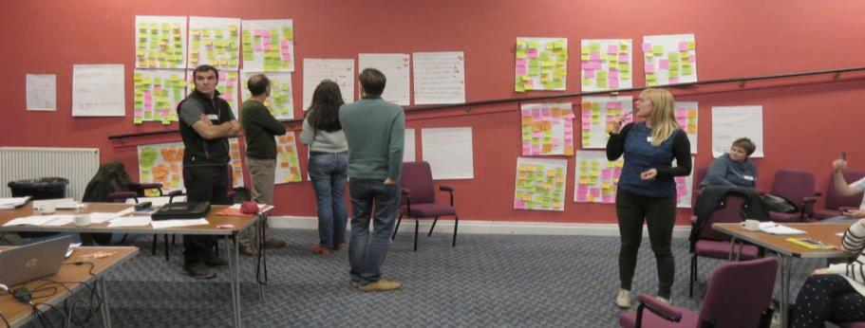
- Hashtags

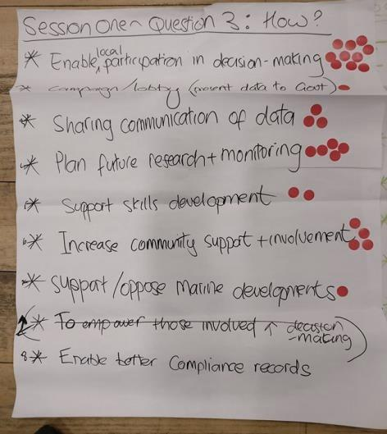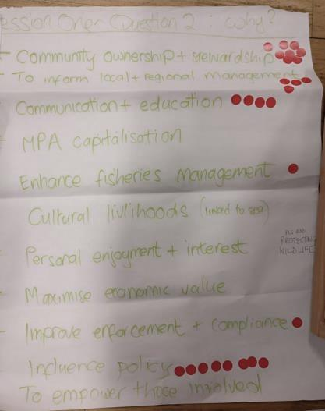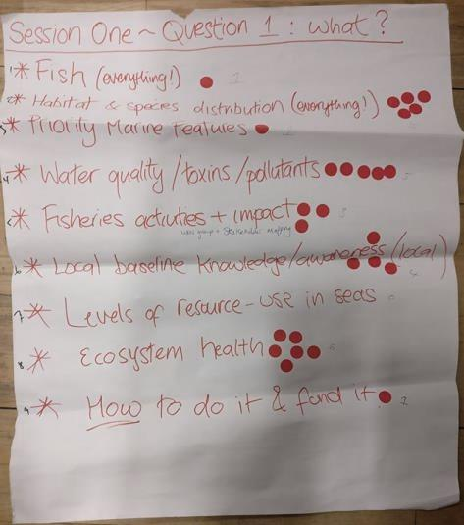
Priorities ranking from Session 1

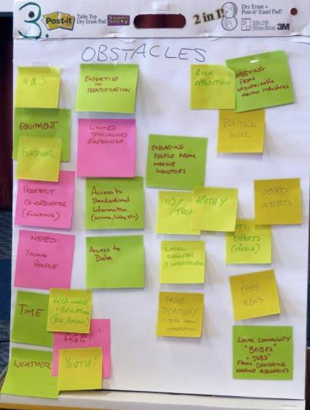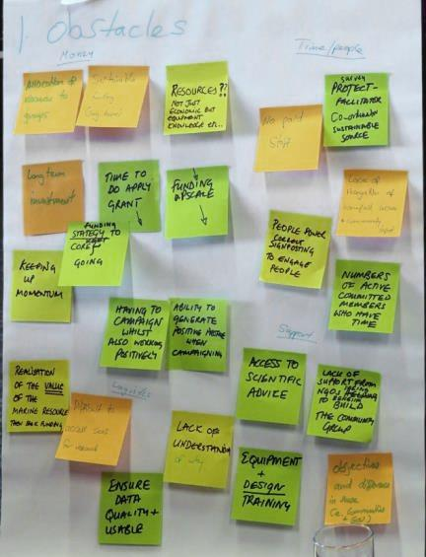
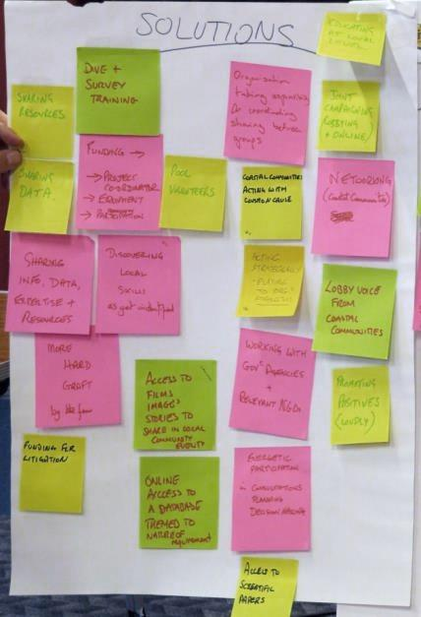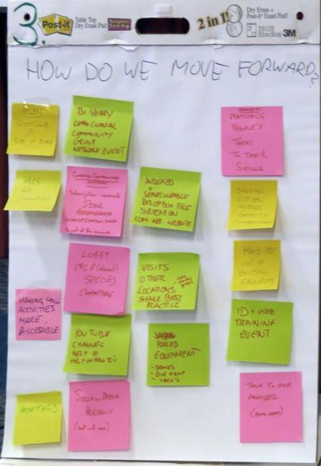
Q1, 2, 3: Obstacles, solutions and moving forward (image J. Merryweather)

